**CART using gini impurity**

Dataset

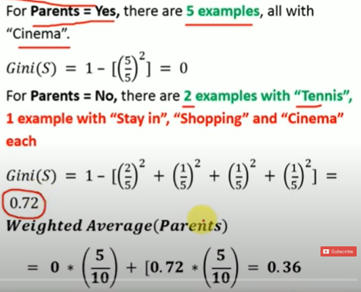

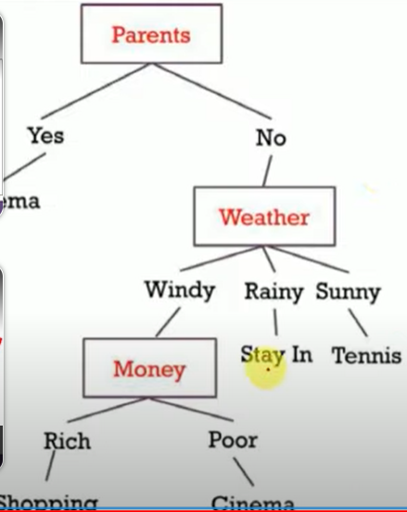

https://www.youtube.com/watch?v=zNYdkpAcP-g&list=PLWTaR9JaaKkuvl27smN459riNXwFATKin&index=1